

Project title

**Development of an autonomous self-driving car using deep learning framework (Phase 1)**

Project Student

**Shin Nishimura (190595E)**

Project supervisor

**Dr Edwin Foo**

1 – Introduction

2 – Objective

3 – Environment Setup

4.1 – Udacity Car Simulator

4.1.1 – Udacity Car Simulator – Flat Track

4.1.2 – Udacity Car Simulator – Mountainous Curvy Track

4.1.3 – User Interface for Udacity Car Simulator

4.2 – Yahboom Jetson Nano

4.2.1 Yahboom Jetson Nano – Regular CNN Method

4.2.2 Yahboom Jetson Nano – Pix2Pix GAN Method

5 – Conclusion

6 – Future Steps

**1 Introduction**

Machine learning algorithms have been implemented for driving on roads. There have been 2 environments and 2 different kinds of vehicles used. First is a front wheel drive vehicle on Udacity’s driving simulator, while the second one is a caterpillar track driving on a large, printed road.

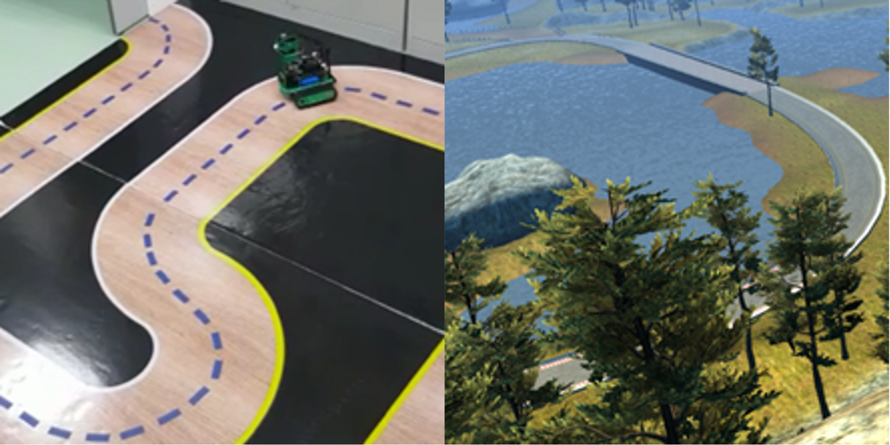

Figure 1a: Road images for Udacity Car Simulator and Yahboom Jetson Nano

Two kinds of driving models were used. The first is a simple Convolutional Neural Network, CNN. CNNs are the main foundations of computer vision, with very versatile use.

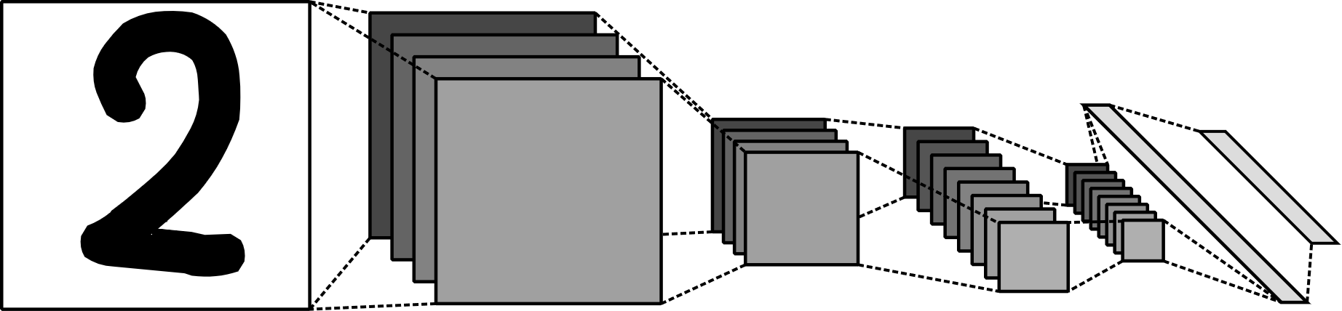

Figure 1b: Simplified Lenet-5 layers visualized.

The second type is a Pix2Pix GAN model, which is a CNN that predicts an image from an image. This model is generally heavier in terms of computation speed.

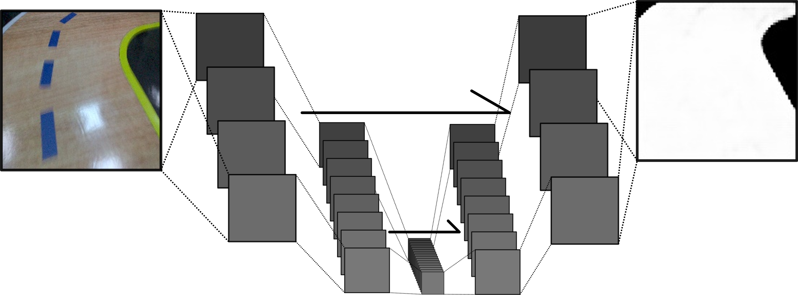

Figure 1c: Simple Pix2Pix GAN model visualized.

The models will then be trained on datasets collected by humans.

**2 Objective**

The main objective of this project is to make sure the car drives autonomously at about human-level accuracy.

The evaluation of the autonomous vehicles will be judged on how well it drives, based on factors, such as the tendency to go off-road and the ability to turn both gradual and steep curves.

These factors will be compared to how well the human drives, accounting for the human’s errors as well.

At the final product, it is hoped that a reliable autonomous car model can be made to drive on any kinds of road.

**3 Environment Setup**

The main language used for this project will be Python-3.8, using Tensorflow-2.3.1

Udacity’s beta version car simulator is a car simulator that has prebuilt functions for autonomous driving, such as the recording function and the autonomous function, where it takes in inputs through a local host network.

The second environment will be set up on a Yahboom robot with a Jetson Nano. Only on this jetson nano, Python-3.6 will be used, but there are no version problems that have arisen due to this for now.

**4.1 Udacity Car Simulator**

On the Udacity car simulator, a self-designed simple CNN model has been used to predict how the car should drive. The model’s inputs being the image and its channels, and the outputs being the steering angle the car should drive on.

Using the record function, one lap of data was collected for both the mountainous curvy track and the flat track with road variations, with the assumption being that the mountainous curvy track will be more difficult for the autonomous vehicle to drive on.

The car consists of one front camera and 2 side cameras, in which the side cameras provide additional data of the cars being off-track. These data are important, as to teach the model how to handle cases when the car goes slightly out of the center of the road.



Figure 4.1a: Sample dataset from all cameras provided.

Images have also been flipped to make sure the model does not get biased on turning either directions. This also gives the model more unique data.

The top and bottom portions of the images have also been removed as though the scenery is nice, it does not really affect how the car should be driving on the track, and the bottom part because the car body is visible on the side cameras. This means that there is a very high possibility that the model might turn left or right based on the presence of the car body on the bottom left or the bottom right of the car, and thus, it has been removed.

The Hue-Saturation-Value color channels proved to work the best, as it substantially increases the ability for the model to find edges. Hue has been removed as it does not tell the model anything of importance about the image.

Augmentation of output has also been performed to make sure that steep turns are possible for the model.

**4.1.1 Udacity Car Simulator – Flat Track**

For the first track, there were different road variations, most notably, the bridge, the dirt path, and the sharp curve portions.

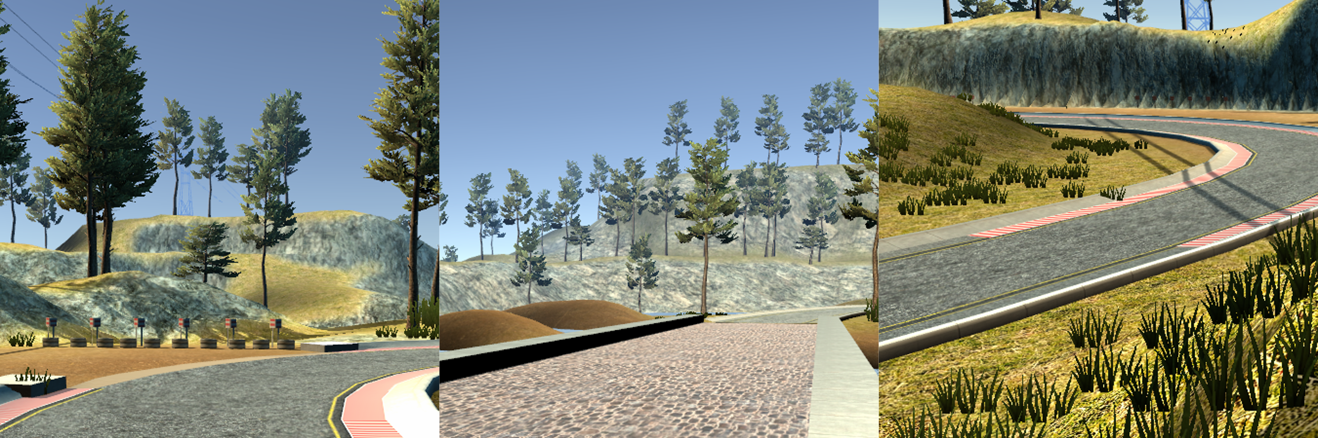

Figure 4.1.1a: Flat track dirt path, bridge, and sharp curve.

The track is going around a lake and will be driven counterclockwise around it when training, and it will be driven clockwise to check that the model is not simply memorizing the images.

This track has been successfully driven by the model, with near human accuracy, though, it has about a 20% chance of failure when turning the steepest curve provided by the track 4,when the model is replicated.

**4.1.2 Udacity Car Simulator – Mountainous Curvy Track**

The mountainous curvy track has uphill and downhill roads, which will provide a challenge. The mountains on the track also cast big shadows on some portions of the road, and there are also other roads that might be a distraction to the vehicle visible at times.

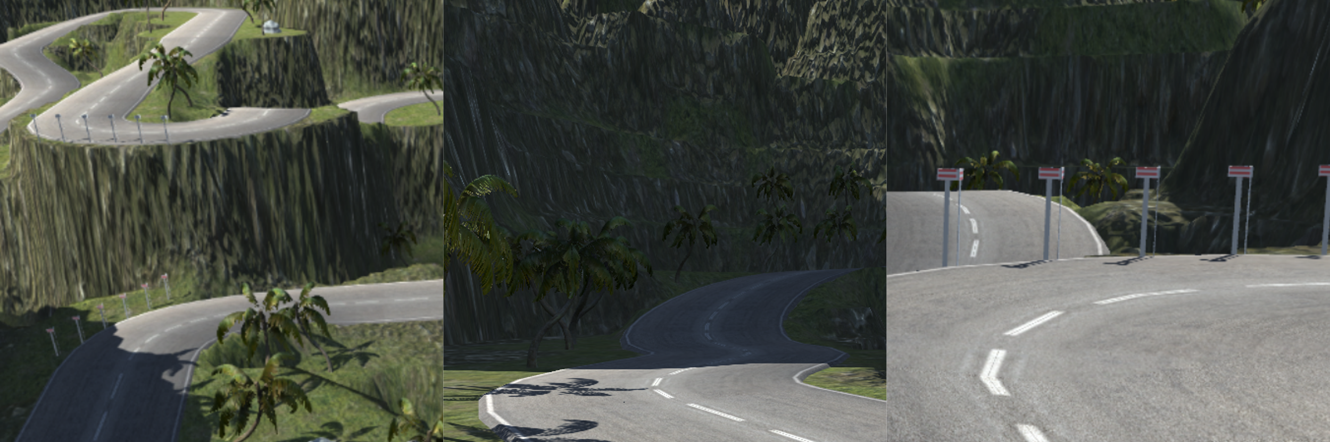

Figure 4.1.2a: Mountainous curvy track challenges.

Visualizing the hidden layers in the model, the shadows on the road are often seen as “portions where there is no road”. This can be fixed with more layers in the model.

Portions of the track with sudden declines also prove a problem that has not been completely solved. This is as the simulation does not really provide a way to slow down the vehicle in an elegant method, and the fact that the human has a third person view of the car when driving makes it more biased for the human driver to perform better. The steep declines make the road past some point not visible, making predictions harder if the vehicle goes full speed across the decline.

Distracting roads proved the biggest problem, as it is nearly impossible to recover from a situation where the model fixates onto a different road, whereas it was still possible to recover from a position that might go off-road.

Overall, these challenges made the vehicle unable to drive at human accuracy. Though humans did not perform well on this track to begin with. More accurate data could be provided through other means.

**4.1.3 User Interface for Udacity Car Simulator**

I have also developed an interface for the Udacity Car Simulator, where people, using the model that has been designed, can train, and run the model on the simulator. Probably useful for open house (if it even happens again) using Python’s Tkinter.

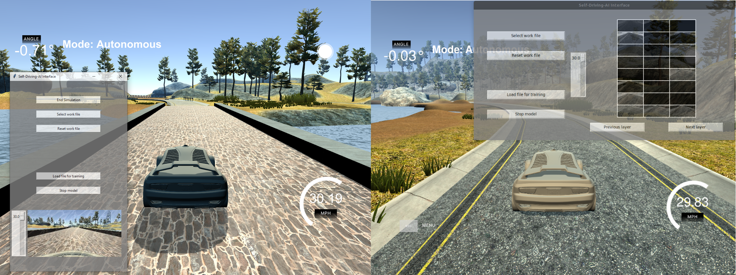

Figure 4.1.3a: Vehicle training UI, left is run on Windows and right is run on Linux Ubuntu.

**4.2 Yahboom Jetson Nano**

The Yahboom robot has a caterpillar track, where it is different from the Udacity’s driving simulator. The final outputs for the following models will be 2, where it predicts the left track’s speed and the right track’s speed. Friction also now plays a larger role.

The other differences to the Udacity simulator will be that there are no side cameras, so image augmentation will be used to achieve different camera angles.

The road that the robot is faced with, has a very shiny surface and this will be harder for the model to drive under certain lighting conditions.

Driving conditions for humans are also different, in this case, with lag complicating the response time of the robot when gathering data.

Battery level also plays a role on the vehicle, where processing speed is significantly slower when the robot is on low battery, which is a huge inconvenience.

**4.2.1 Yahboom Jetson Nano – Regular CNN Method**

Using a very similar model to the Udacity model, with about 100 thousand parameters, the vehicle was able to drive along its training path, but not when driving from the opposite direction. This was seen due to the road’s reflective nature, as when the light glare on certain curves were blocked, the vehicle was able to turn perfectly fine.

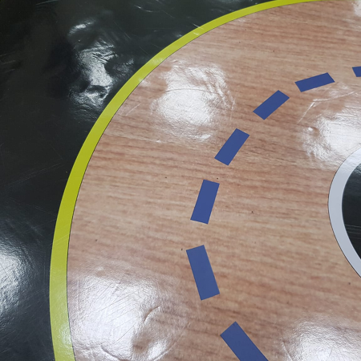

Figure 4.2.1a: Light glaring on road.

From my previous experiences with the distracting roads, I have concluded that the next Pix2Pix GAN method is going to be superior and more versatile, as this model will merely map out where the road is, and any other model will be able to predict how to drive from the predicted result.

**4.2.2 Yahboom Jetson Nano – Pix2Pix GAN method**

After creating a rather computationally light Pix2Pix GAN model, with about 1 million parameters, this is an example of how the road will be processed.

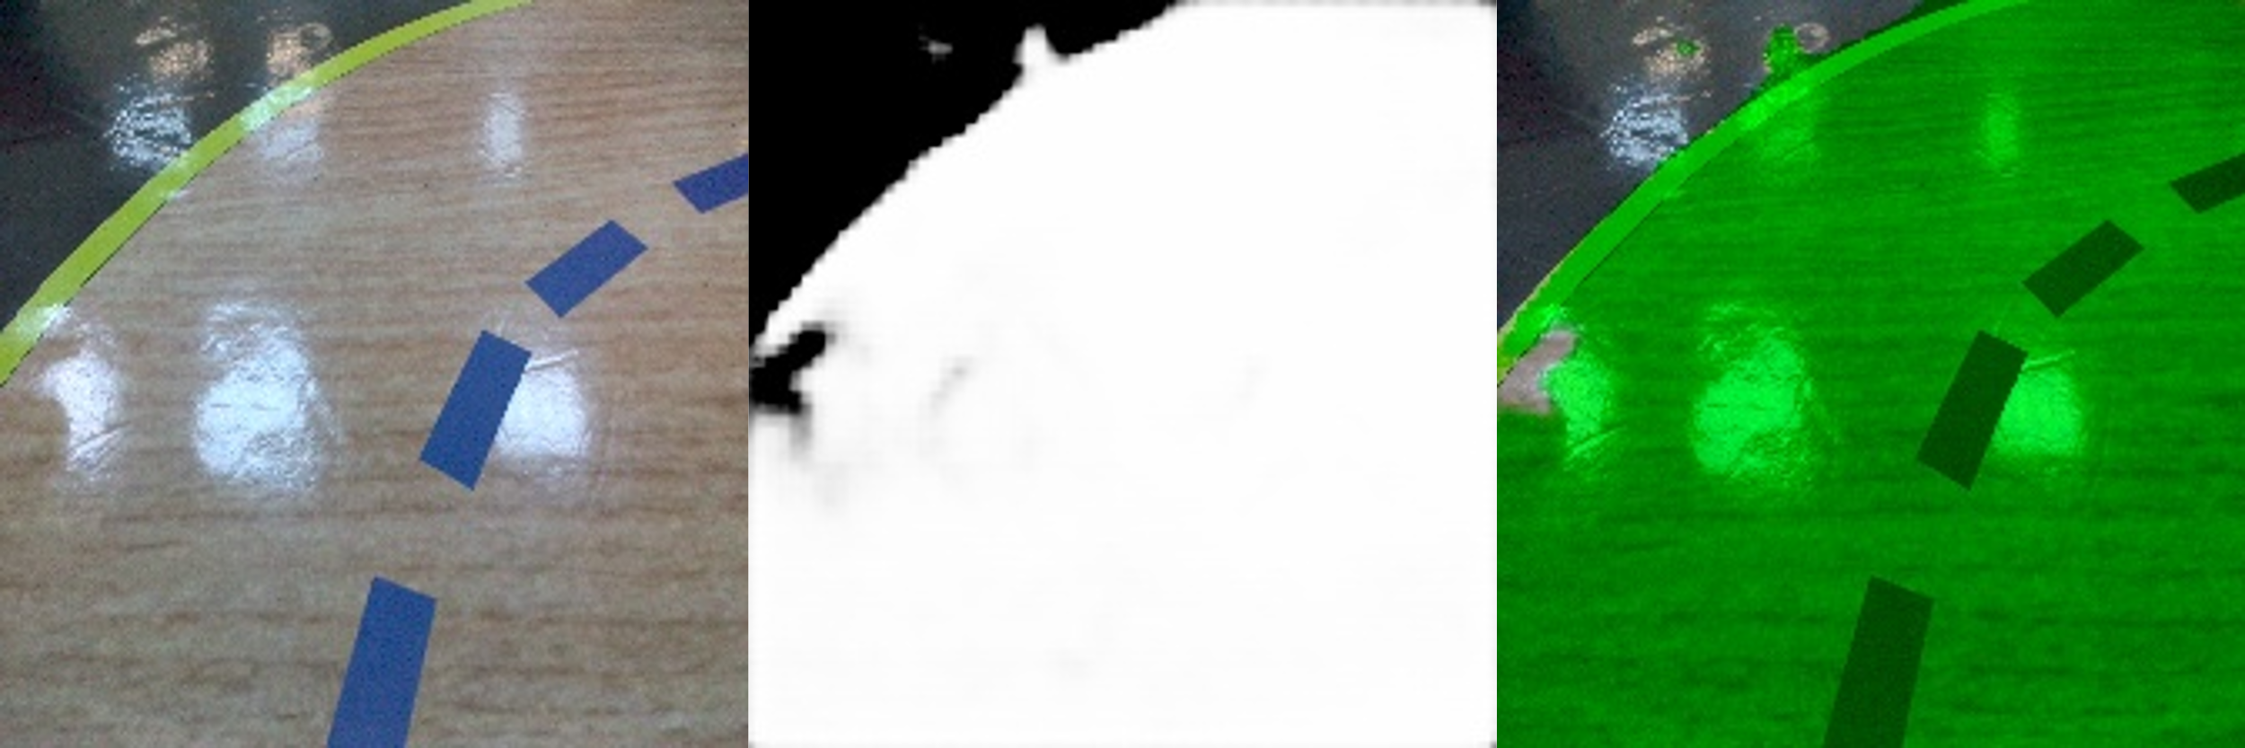

Figure 4.2.2a: Masking model in action.

The image output data was made manually using, Inkscape, a vector art software.

The limitation to this is that the sheer number of total images makes that labelling 50 or so images (which was done) only amounts to 8.3% of the total images collected from the training set, and thus making it slightly unreliable. To counter this, large-scale distortion will be used on the second model during training, such as salt and pepper, which adds random white and black pixels onto the input image.

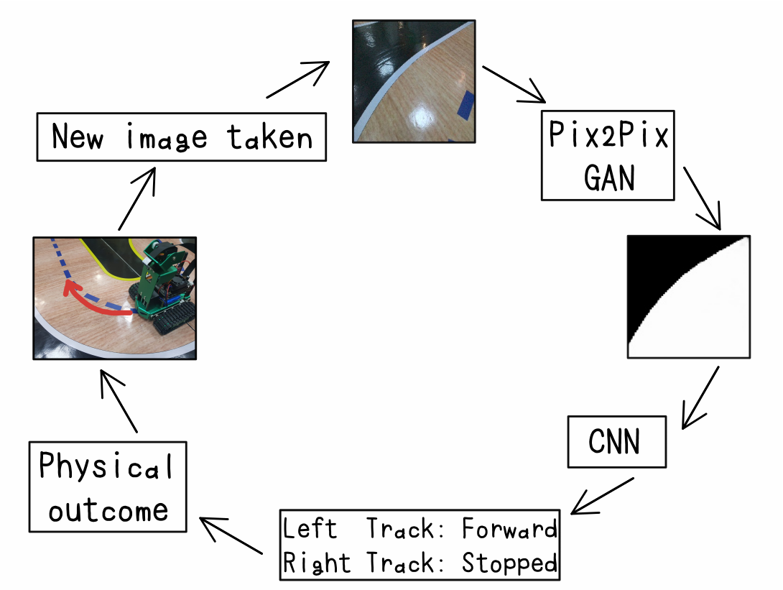

Figure 4.2.2b: Data pipeline illustrated.

This method also has an advantage of being able to fabricate datasets, where you can just draw random curves on images and call it a road image. This has been done to create datasets with ease where the robot should do a pivot turn, which was not done during the training recording.

With those 2 implemented, however, the robot will only move at about 6 to 7 predictions a second, which will result in jagged movements when battery level is high, and when it is at medium or low, it will be outright bad, going off-road at curves.

This shows that the Jetson Nano is slow in computation, and to drive with good accuracy, a model in it should only have up to about 200 thousand (Not tested) parameters, while the current one has 1.1 million.

**5 Conclusion**

This project has given insight for autonomous vehicles in different ways. The ideal model has also been seen as the image-to-image model, if computation power is strong enough, Else, the regular CNN model will be better, taking the fact that the slower model will not be able to react fast enough to turns.

Running a vehicle on a two-wheel drive or a caterpillar track will also need to be taken in account, especially when creating a steering bias when augmenting or taking an image from a different angle. This includes things such as the higher amount of friction the caterpillar track makes.

Comparison of the vehicle’s performance in comparison to the human’s is also seen to be slightly ineffective unless the human can drive with the same provided data the AI is given. This also makes it that the AI will never surpass human driving standards, so long it is a human that is training it.

**6 Future Steps**

For next steps, I see that modifying the open source Udacity model will be a great place to start. The Udacity model is made on Unity game engine, which is run on C#.

From this, I believe a model can be created for self-learning of the AI vehicle, which is the goal of this project. This future model can probably contain a very effective image to image prediction model to mask out portions of the road, with object detections, such as street signs and humans.

Lane detection is also an idea that might be achievable with the image-to-image model, so that the vehicle can not only detect the whole road, but the lane the car should be driving on, and what to do when it should switch lanes.

Usage of a discriminator on the image-to-image model could be a possibility when coming into predicting harder images.